Now it’s time to take that beautiful ask you wrote and ask for a gift!

Step 1: consider how to frame your ask for your people
Thinking back to what you wrote in the first worksheet about what kind of fundraising might feel good to you and your people, take the space here to adapt your ask to each board member.

Step 2: CONSIDER HOW YOU WILL MAKE YOUR ASK
Take a peek at the chart below about fundraising effectiveness. Given what you see, how do you want to ask your board members?
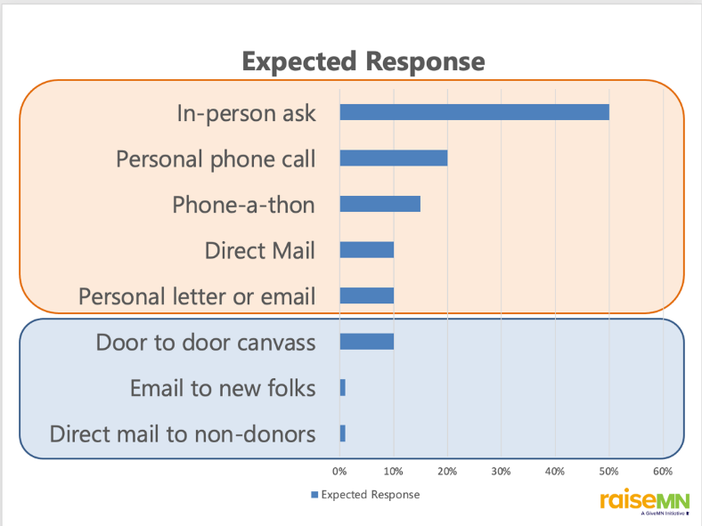

Note: “in-person asks” are 1:1 meetings, not board meetings or group settings, which aren’t included here since their rate of return is very unpredictable.

Step 3: PREPARE FOR THEIR ANSWER
Be ready for whatever the answer is after they ask. What will you do when you receive each of these answers? How will you thank them for their gift?

Yes
No
Maybe

